**A 300MHz Active Probe Design**

**Objective:**

Typically, passive probes are commonly used in standard electronics laboratories. These probes consist of passive components, such as resistors and capacitors, which can load the circuit at higher frequencies. Consequently, the bandwidth of passive probes is limited to approximately 500MHz. To measure signals at higher frequencies without introducing loading effects, active probes are more suitable. Active probes primarily employ an op-amp in a voltage follower mode, offering high input impedance and minimal input capacitance, which results in reduced signal distortion and minimal loading. The selection of an op-amp is critical in the development of an active probe. This paper examines the design to create a low-cost probe with measurements facilitated by a low-cost nano VNA and also the key parameters to consider during choosing an op-amp, supported by measurements of the OPA858 op-amp.

**Characterization of Op-Amp:**

**Maximum and Minimum Voltage Measurement:**

The selected op-amp must be capable of operating with a dual power supply to avoid clipping the negative portions of an AC signal. It's essential to evaluate the minimum and maximum output voltage, considering factors such as dropout voltage, noise, and offset.

*Figure 1* (left)demonstrates that the OPA858 can detect signals as low as 10 mV. (right)Despite being rated to operate with a 5.5V peak-to-peak supply, it outputs a 3.4V peak-to-peak due to a dropout voltage of 0.9V. After accounting for noise, the comfortable output range is approximately 3.2V peak-to-peak.

From datasheet:



**Gain and Bandwidth:**

For accurate signal measurement, a buffer is required to sample the signal without distortion or loading. The op-amp is thus configured in voltage follower mode to leverage its high impedance, capturing the signal with minimal distortion. A Bode plot is useful for evaluating the transfer function between gain and bandwidth, though the S21 parameter response measured by a VNA offers an alternative. Over the operating bandwidth, the S21 remains stable, decreasing beyond this range.

+6dB gain

*Figure 2* (left): The S21 response of the OPA858 in voltage follower mode shows a 6dB gain instead of the expected 0dB due to the op-amp’s high impedance. (right)With a reflection coefficient close to 1, at the conjunction of trace and non-inverting terminal op-amp sees double the amplitude of incident signal, resulting in a 6dB gain. From visual inspection, it’s evident that the OPA858 achieves an approximate 2 GHz bandwidth for small signals (<200mV peak-to-peak) as tested with the nano VNA which operates at -10dBm output power.*Figure 3* provides further analysis with larger signals, including 14dBm (3.16V peak-to-peak) and 4dBm (1V peak-to-peak), using a ZNL VNA capable of variable output power. This analysis narrows the operational bandwidth to around 320MHz.

From data sheet:



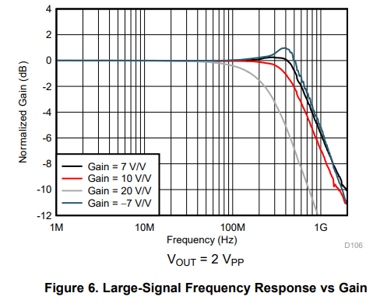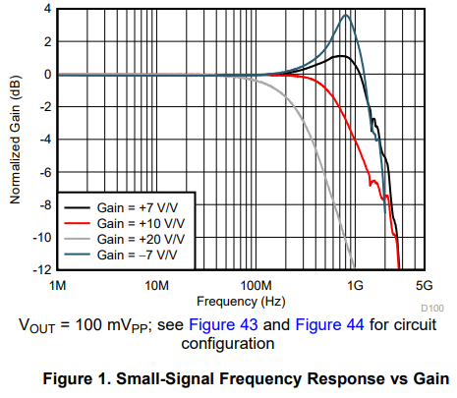

*\** Also include a comparison between the nano VNA amplifier and attenuator measurements.

**Measuring Input Impedance and Input Capacitance:**

To prevent signal distortion, the op-amp input bias current should be low, with high input impedance and minimal input capacitance, thus reducing circuit loading. Calculating these values provides insight into the input bias and potential signal distortion level.

*Figure 4* demonstrates S11 measurements, allowing for calculation of the input impedance using Z=50×(1+S11)/(1−S11)​, which is around 10KΩ. The imaginary part of this impedance yield value for input capacitance approximately about 4pF.

From datasheet:



**Measuring Rise Time and Slew Rate:**

As discussed in [Signal Integrity Journal](https://www.signalintegrityjournal.com/articles/2092-bandwidth-of-signals-what-is-important-rise-time-or-slew-rate), rise time and slew rate are same at small amplitudes and they help defining signal quality at higher frequencies. The rise time also provides a bandwidth estimate.

*Figure 5* shows a comparison of 30ps pulse generated and applied to the op-amp, resulting in an output signal of rise time 557 ps. This corresponds to a calculated bandwidth of approximately 628MHz (BW = 0.35/Rise time).

From datasheet:

With small signal, not able to see twice the amplitude of incident signal?

So what?

References:

* https://www.ti.com/product/OPA858